**EventHub User Manual**

**1.0 Product Overview**

EventHub is a social networking application centered around helping people find events that are happening in their areas. EventHub can be used to host any type of event imaginable, and as more users add events to the website, more events become available to users around them. It is in this exchange of information that EventHub finds its purpose – to connect people to what is happening around them. Anytime you are having trouble finding something to do, EventHub can help.

EventHub’s core functionality is to provide a means for users to search for events happening in their areas. This is primarily accomplished using the search bar located on the homepage. Perhaps as equally important as providing a means for users to search for events is allowing users to create events. The database of events grows faster as more users post what events are happening around them, thus increasing the search space for other users.

**2.0 Getting Started**

The following sections will provide an overview of how to log into EventHub, where to find help when you need assistance, and a couple of sample runs using the functionality of EventHub.

**2.1 Log In**

Logging into EventHub is very simple. At the top-right corner of the homepage, find the textboxes labeled “Username” and “Password.” Once you have located them, type your username into the “Username” box, and then type your password into the “Password” box. Once you have entered both fields, click the orange “Login” button next to the password field, and you will be logged into your account. Below is an image of the homepage with a red arrow pointing to the username and password fields and the login button.

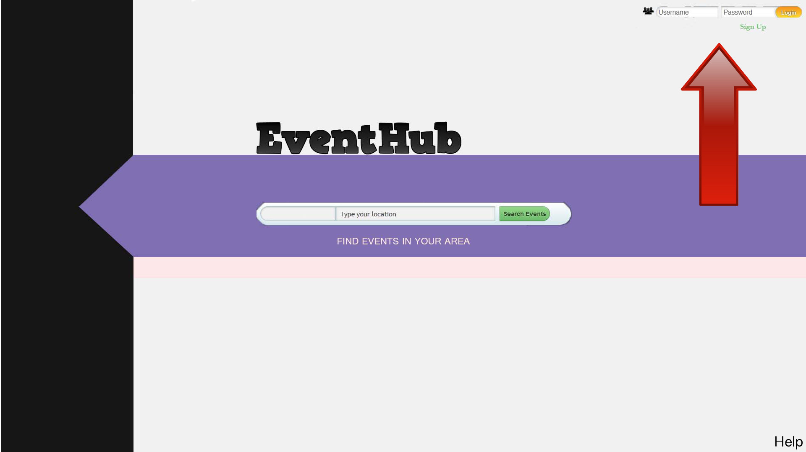

**2.2 Help Mode**

If you encounter a problem while using EventHub, please access our Help section by clicking on the word “Help” on the bottom right corner of the homepage. The Help section will consist of a page of Frequently Asked Questions (FAQ’s). Scan the list of questions and read the answers to questions that are similar to the issue you are having. For example, if you are not able to create a new event, read the answer to the question “Why can’t I make a new event?”

If accessing the Help section of our website did not assist you with your issue, please send an email to admin@eventhub.com so that your request can be processed. Please briefly indicate what your issue is in the subject line so that we can respond more efficiently. In your email, please specify what issue you are having with our services, when you first experienced this issue, what web browser you were using when you experienced this issue, and if possible, the steps you performed that led you to have this issue (e.g. I logged into my account, typed my location in the search bar, clicked to search for events, and then my results never loaded).

While you wait for our response, feel free to investigate the next section of this manual (2.3 Sample Runs) to see if the issue you are having has been addressed there.

**2.3 Sample Runs**

Creating an Event

To create an event, complete the following steps. Begin by typing your username and password into the fields located at the top-right of the homepage, and then click the “Login” button to sign into your account. Next, click on your username to access your account screen, and then find the “Create Event” button. Click the “Create Event” button to access a new screen where you can enter the relevant information for the event you want to create. When you are satisfied with your choices, click “Submit Event” for your event to be posted. Below is a more detailed description of the process.

1. On the homepage, the login fields are located at the top-right corner of the screen. To enter your username, click in the “Username” box and type your username. To enter your password, click in the “Password” box and type your password. Then click the orange “Login” button to sign into your account. The image below has a red arrow pointing to where you can find the login fields.



2. Once you login, you will still be at the homepage, except now you will be signed into your account. Notice that the “Username” and “Password” fields have been replaced by your account name (in this example, EH_User is the username). Click on your username to access the account screen.

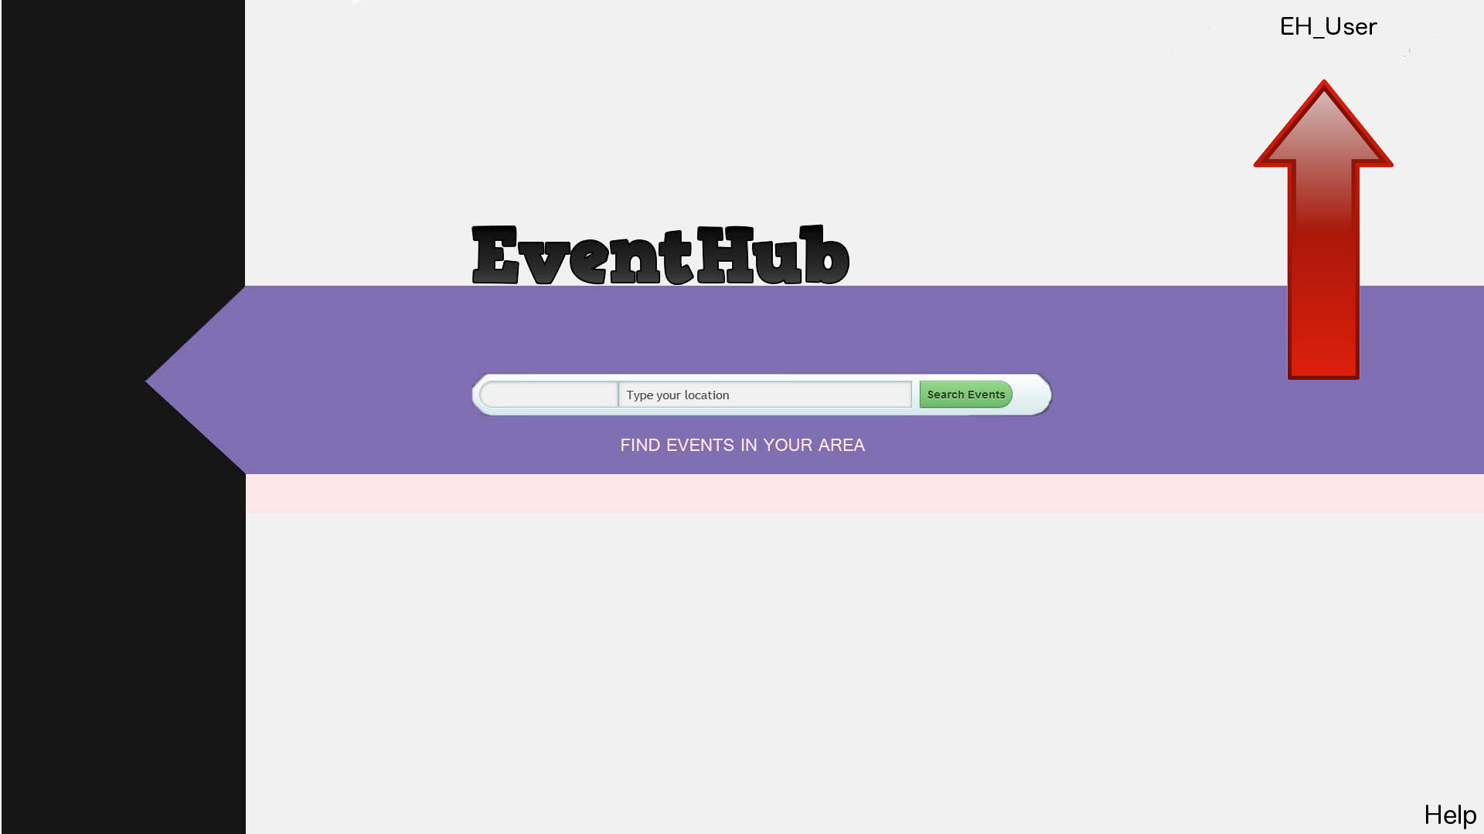

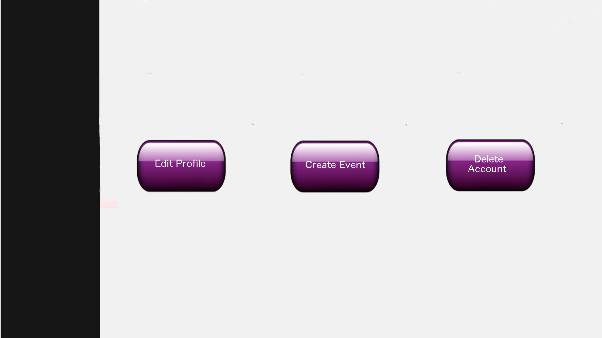3. Below is the account screen. To begin creating a new event, click the middle button labeled “Create Event.”

4. You will now be at the screen shown below. Here, you can enter the details of the event in the corresponding fields (in this example, the event is a book sale being held by the Cathedral of Learning in Pittsburgh):

a. Event Name – Click in the textbox titled “Event Name” and give the event a name (this is the first field people will see when looking for an event so choose a good name).

b. Description – Click in the “Description” box and summarize the event.

c. Location – this field is divided into more specific details

i. State – Click in the “State” textbox and enter the state of the event (e.g. Pennsylvania).

ii. City – Click in the “City” textbox and enter the city of the event (e.g. Pittsburgh).

iii. Street – Click in the “Street” textbox and enter the street the event is on (e.g. Bigelow).

iv. Other – Click in the “Other” textbox and enter other information that might help people find the event (you can leave this field blank).

d. Date – Click in the “Date” textbox and enter the date the event will take place. (e.g. 10/12/13)

e. Time- Click in the “Time” textbox and enter when the event will take place on the given date (e.g. 12 p.m. to 5 p.m.).

f. Event Privacy – Click the button next to “Public” to indicate the event is open to the public. Click the button next to “Private” to indicate the event is private.

5. Once you are satisfied with you choices, click the “Submit Event” button to have your event submitted. You have now created an event!

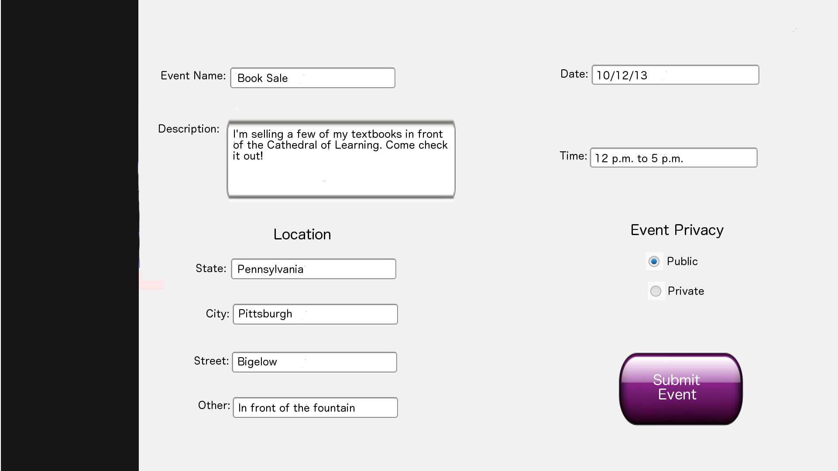

Unable to Search for Events

The following scenario will demonstrate a user being unable to search for events using the search functionality on the homepage. The main cause of this is that the user is not signed into his or her account. In order to utilize EventHub’s search functionality, you must be signed into your account.

When you are at the homepage and not signed into your account, clicking in the search box will cause a pop-up box to appear stating, “Please sign into your account.” Click “Ok” in the pop-up window to close it, and then proceed by signing into your account. After signing in, you will be allowed to click inside the search box and begin searching for events. Below is a more detailed description of the scenario.

1. On the homepage, the user has clicked in the search box, causing the pop-up window to appear stating, “Please sign into your account.” Notice that in the top-right corner of the screen, the username and password fields are present, thus indicating that the user is not signed in. Click “Ok” in the pop-up window to close it.

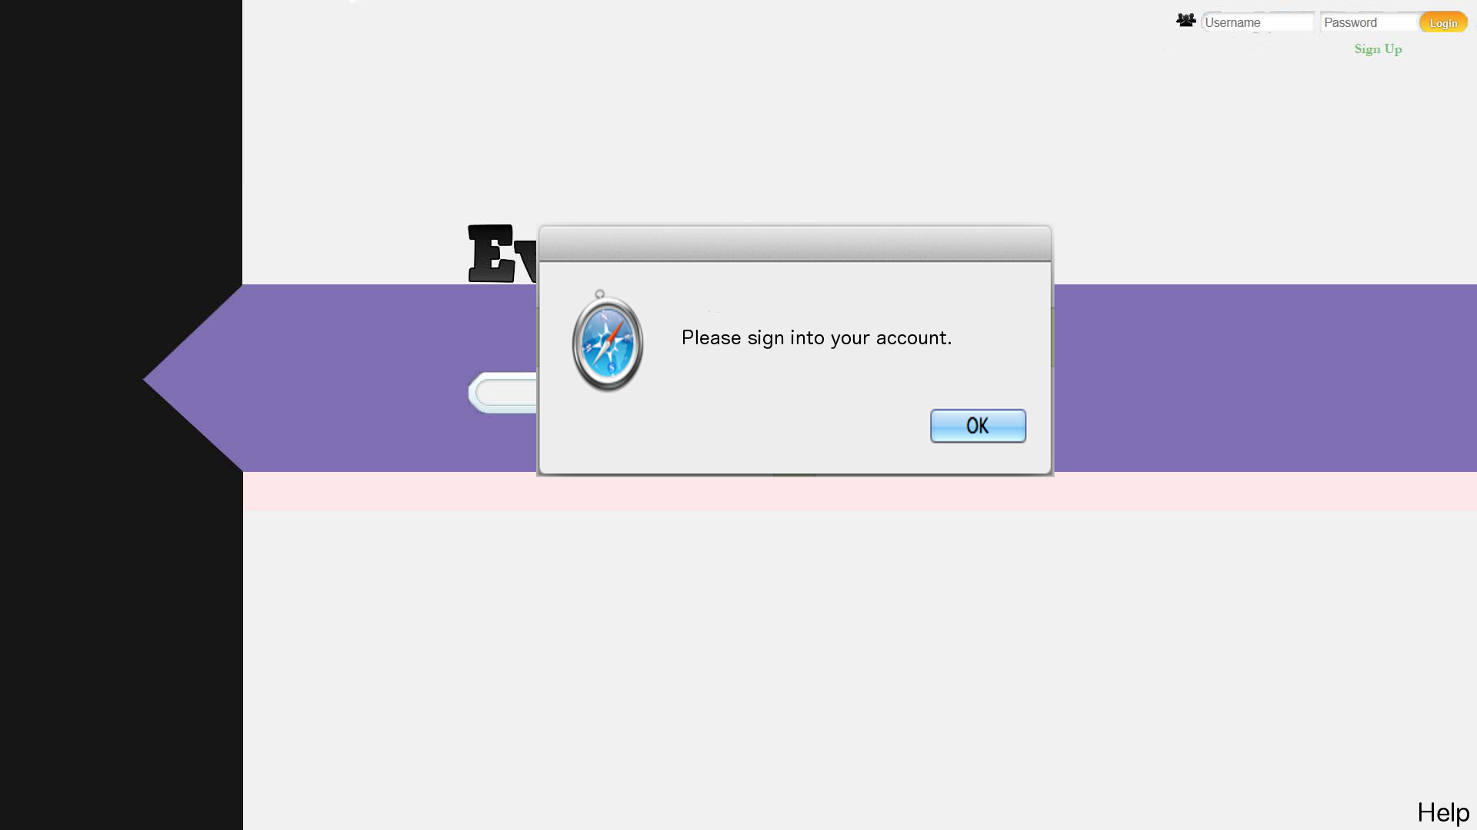

1. Next, you will still be at the homepage, except the pop-up window is gone. If you attempt to click into the search box again, you will receive the same pop-up message (refer to step 1. if the pop-up appears again). The next step is to sign into your account using the username and password fields at the top-right of the screen. To enter your username, click in the “Username” box and type your username. To enter your password, click in the “Password” box and type your password. Then click the orange “Login” button to sign into your account.
2. Now that you are signed into your account (in this example, the username is “EH_User”), you can click in the search box without receiving the pop-up message and begin searching for events. Notice in the image below that in the top-right corner of the screen is the user’s username, indicating the user is signed in. Also notice the line in the search box waiting for input, indicating that the user has successfully clicked inside the search box without receiving the pop-up. Please refer to section 2.2 (“Help Mode”) if further assistance is needed or if these steps did not help with this issue.

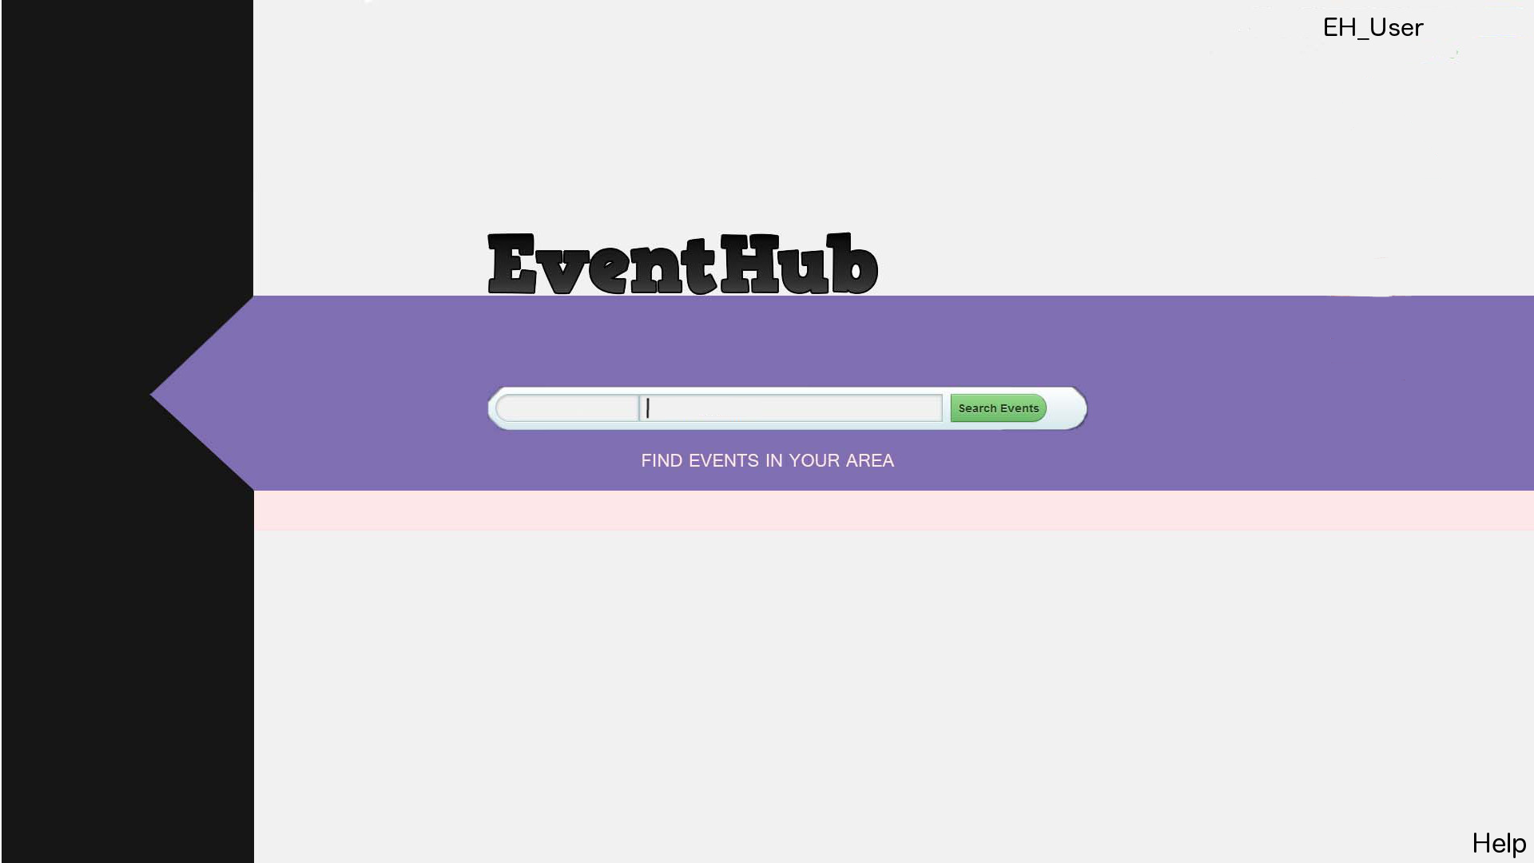

**3.0 Modes of Operation**

There are three main modes of operation that the user utilizes while on EventHub – textboxes, buttons, and drop-down menus. All three of these modes of operation are used in a variety of roles and receive different types of input.

The user uses textboxes in a few different ways. One of these ways is by typing search queries into the textbox on the homepage to search for an event. A typical query consists of the name of the user’s city so that events happening in the user’s city appear in the search results. Textboxes are also used for entering data. For instance, when a user attempts to create an event, he or she must enter information about the event into textboxes (e.g. location of the event, date, time, etc.). The login process is also an instance of using textboxes as a means to enter data (the data being the user’s username and password). Below are examples of the uses of textboxes.

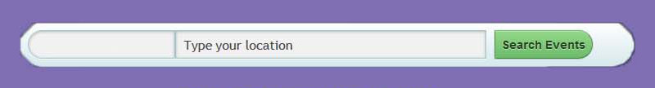 Image 1.) Search textbox on the homepage

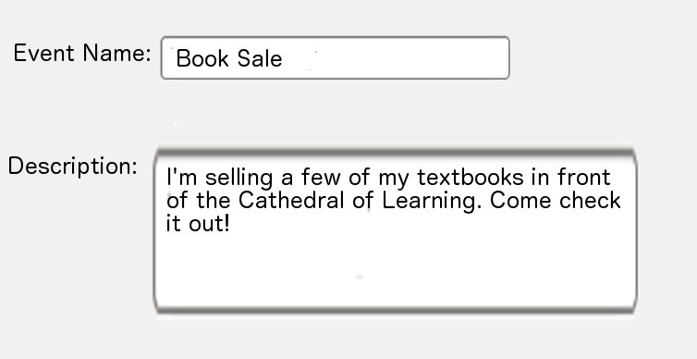 Image 2.) Textboxes for entering data when making an event

Buttons are mainly used to confirm the submission of data and choices. This submission process is done in many different contexts. For example, when a user wants to sign into his or her account, he or she must click the “Login” button to submit the relevant data needed for the login process (username and password). Similarly, to submit an event, the user must click the “Submit Event” button so the event’s data can be processed and posted. When a choice must be made, buttons dictate what choices are available. For example, a user must decide to click either the “Public” or “Private” buttons when creating an event to decide if the event is open to the public or private. Buttons also guide users’ choices on their account page when they have the option of editing their profile, creating a new event, or deleting their account. Below are instances of buttons used for submitting data and choices.

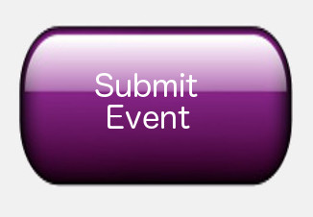 Image 1.) Buttons used for submitting data

Image 2.) Buttons used for making choices

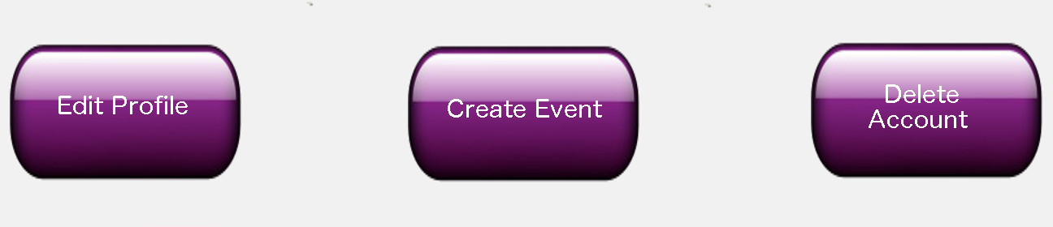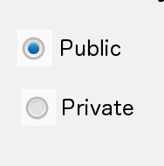

Lastly, drop-down menus are used to enumerate choices for the user. Their purpose is similar to a button’s purpose, but they are used when enumerating choices over buttons would be too cumbersome. The main instance of drop-down menu usage is on the homepage. Next to the search box, in which the user enters a search query, is a drop-down menu that enumerates different types of events. Examples of types of events are artistic, music, school, sports, other, etc. The user clicks within the drop-down menu to bring up the options, then highlights and clicks an option that best suits what he or she is searching for (the user can opt not to use the drop-down menu). In this instance, the drop-down menu options are used for filtering search results. Below is an image of the homepage drop-down menu being used.

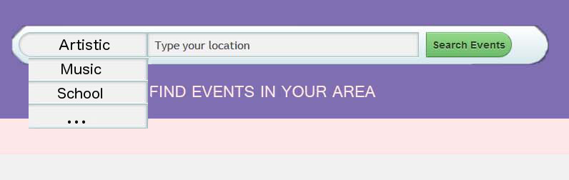

**4.0 Advanced Features**

EventHub’s advanced features are focused on the user’s location and how that relates to events happening around the user. EventHub offers two main advanced features – the ability to see how far away an event is from the user and an events feed that lists events happening near the user.

When a user is searching for events, it is probably important for him or her to know how far away the search results are. For instance, a user looking for local concerts happening around the Pittsburgh area is probably not interested in shows that are happening in Chicago. With the aid of Google’s map functionality, EventHub reports the distances from the user’s location to the events of the search results. This is accomplished using the location information from the user’s profile along with the locations of the events in the search results to obtain a distance calculation. Search results are then ranked by proximity – the closer the event is to the user, the higher up in the search results the event will be. Using Google’s map functionality, directions to each event are provided once a user selects an event from the search results.

The events feed, EventHub’s second advanced feature, is a self-updating column of events on the user’s profile page. This column of events updates once per minute, listing events by proximity – closer events being listed at the top of the feed. The way to think of the feed is that it is a continuous search for local events, the results of which are provided without the user directly searching. The reasoning for this functionality is that the user might miss an event in their search; thus, the feed allows for the user to see a greater quantity of events, increasing the likelihood of him or her attending an event.

EventHub believes these advanced functions will enrich the experience of the user by making event searching more convenient and available.

**5.0 Glossary of Commands and System Options**

Button: a utility allowing a user to select or submit a command

Create Account: the action of creating an account on EventHub; a person must have an account to use EventHub’s services

Create Event: the action of creating a new event on EventHub; events can be either public or private

Delete Account: the action of removing a user’s account from EventHub; once deleted, an account cannot be recovered

Drop-down menu: a utility showing a user a list of available options

Edit Profile: the action of changing one’s public information on EventHub; e.g. submitting a new profile picture

Event: an incident of interest; a significant occurrence happening that a user submits to EventHub; other users can find this event if the event is public

Event Feed: a listing of events happening near a user; updates itself with new search results about once every minute

Login: the action of signing into one’s account; the process of being able to access a user’s profile

Password: used in conjunction with the username during the login process; passwords are only for the individual user’s use and are important for ensuring a secure account

Profile Picture: a picture that users identify themselves by; an icon that quickly conveys personhood

Private: in relation to an event – only certain users can see the event

Public: in relation to an event – any user can see the event

RSVP: term used to describe a user indicating that he or she is attending an event

Search Events: the action a user performs when he or she wants to find events; usually done by submitting a search query via clicking a button

Search Query: the relevant information a user enters when he or she wants to find events; usually involves selecting drop-down menu options and entering information in textboxes

Select: when multiple options are provided, the user chooses which option among the given list of options he or she desires; usually presented in a drop-down menu

Submit: when a user is satisfied with his or her selections, he or she provides the service provider with the information; usually done via a button

Textbox: a utility allowing a user to enter information; e.g. the description textbox on the event creation page allows users to enter a description of the event being created

Username: a title that users identify themselves by

**6.0 Installation Procedure**

EventHub is a web-based system; therefore, the source code is stored on the host provider, and no installation is required. With regards to the source code, it can be collected into a zip file, moved to any platform, and be reuploaded (unzipped) there.

**7.0 Software Maintenance**

Source code can be found at cs1530.nfshost.com and also from our GitHub repository, github.com/CS1530-G7/EventHub. From there, the code can be downloaded for modification. Because the code is web-based (PHP), code is processed on the server after it is reuploaded to the host. Once the code is reuploaded, the changes will appear on the actual website. This is the procedure used during the testing phase when modifications were being made to the code, and it has been successful for those endeavors.

**8.0 Revision History**

|  |  |  |
| --- | --- | --- |
| **Date** | **Section** | **Description** |
| 10/13/13 | 4.0 and 5.0 | Added advanced features and glossary sections |
| 12/2/13 | 6.0 and 7.0 | Added installation and maintenance sections |